MSK REFERRAL FORM
PLEASE NOTE: Patients with symptoms of cauda equina compromise should go for acute orthopaedic admission agreed over the phone and NOT the Spine Service. This referral form EXCLUDES referrals for fracture clinic, urgent A&E referrals and suspected cancer 2WW

Referral Date |  | Long date letter merged |  |  |  |  |  |  | NHS No |  |  | NHS Number |  |  |  | BMI |  |  |  | Gender |  | Gen der
Urgent referral |  |  | If urgent please state reason
Patient Full Name |  | Full Name |  |  |  |  |  |  |  |  |  | DOB |  | Date of Birth |  | Referring GP Name |  |  |  | Usual GP Full Name
Registered GP Practice |  | Organisation Name Organisation Full Address (single line)
Patient Address |  | Home Full Address (single line)
E-mail |  | Patient E-mail Address |  |  |  |  |  |  |  |  |  |  |  | Pref. Tel. |  | Patient Home Telephone
Contact Number |  | Patient Home Telephone / Patient Mobile Telephone |  |  |  |  |  |  |  |  |  |  |  |  |  | Consent to leave message?
Ambulance transport? |  |  | Details
Occupation |  |  |  |  |  |  |  |  |  | Interpreter Required? |  |  |  |  |  | Which language?
Patient OFF WORK due to condition? |  |  |  |  |  |  | If yes, how long for?
ANATOMICAL SITE: Knee |  |  |  | Hip |  |  |  | Hand&Wrist |  |  |  |  |  | Foot&Ankle |  |  | Pain |  |  | Spine
Shoulder &Elbow |  | Rheumatology |  |  |  |  |  | If requesting DIRECT ACCESS PHYSIO please tick this box
Please give a brief history and reason for referral (date of onset, comorbidities etc.)  Please note that PMH and medications will auto-populate from your clinical system into the bottom of this form. |  |  |  |  |  |  |  |  |  |  |  | SYMPTOM DISTRIBUTION (Please mark on chart or drag and drop the symbols)  PAIN: NUMBNESS:  PINS & NEEDLES: SWELLING:
 |  |  |  |  |  |  |  |  |  |  |  | 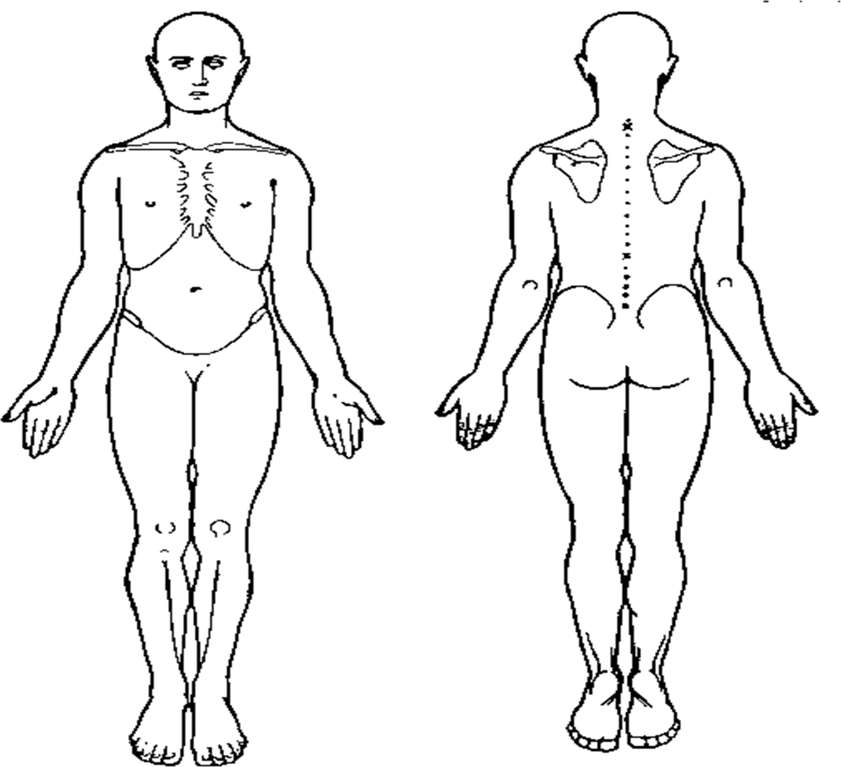
Previous treatment: (Successful or not including physiotherapy, osteopathy etc.) |  |  |  |  |  |  |  |  |  |  |  | Previous investigation: (Please attach reports)
Any Red Flags? Please list in the blank box below:
Please note that Red Flags include: |  |  |  |  |  |  |  |  |  |  | Immunosuppressed (other than steroids) |  |  |  |  |  |  | Hx of serious pathology
Unexplained weight loss (> 10% body weight in last 3-6/12) |  |  |  |  |  |  |  |  |  |  | Severe, unremitting night pain |  |  |  |  |  |  | Gait disturbance
Progressive weakness and/or sensory loss |  |  |  |  |  |  |  |  |  |  | Rapidly worsening neurological  symptoms |  |  |  |  |  |  | Hx of systemic illness
Additional details:
Medication
Medication

Medical History (Active Significant, Active Minor, Past Significant)
Problems

Allergies
Allergies

PLEASE ATTACH ALL REQUIRED REPORTS, PREVIOUS CORRESPONDENCE AND ANY FURTHER INFORMATION REQUIRED

