# Adding ICE Numbers to SystmOne

Once the user has been added by the lab they will send the spreadhseet back. Each user will have a new number next to their name (this will be NWX followed by two numbers another letter and two numbers e.g NWX03A99

|  |  |
| --- | --- |
| 🗹 | Remember   * If you have added a GP or Consultant to the Spreadsheet you may need to check that they have been added to SystmOne using their GMC number |

To add a Pathology Number to a SystmOne profile:

1. Open SystmOne
2. Go to **Setup > Users & Policy> Staff & Organisation Setup**

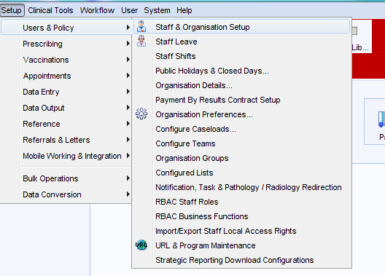

1. Find the staff member from the list, **right-click** and select **Amend staff.**
2. In the **Professional Details** section click the dropdown and select **Pathology ID**

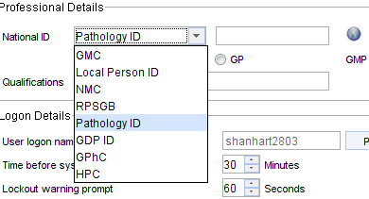

1. Enter the Number from the spreadsheet in the box to the right and click **Ok**