**First Contact Practitioner - EMIS Web**

**Practice Installation Guide**

**Document History and Control**

|  |  |  |  |
| --- | --- | --- | --- |
| **Version** | **Date** | **Brief summary of change** | **Reviewer** |
| V1.6 | 19th November 2020 | Reformatted document | CH |
| V1.7 | 24th November | Additional screen grabs / guidance | CH / SH |

# **Introduction**

This document will guide you through the installation of the FCP Resources for EMIS Web so that your FCP has all the tools necessary to effectively manage patients through their journey.

# **Installing the EMIS Web Resources in Your System**

In the same email in which this document is you will find a .zip file named **FCP_EMISWeb_Resources.zip**

1. In your email **right-click** the folder and select **Save Attachments** (Outlook Desktop) **OR** **Download** (NHS Mail Web Portal):

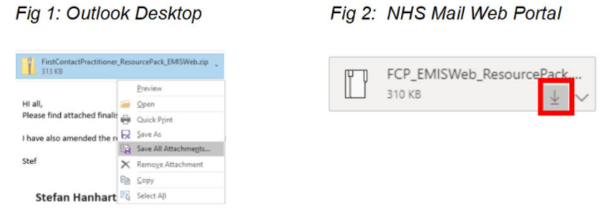

1. Navigate to where the file has been extracted to, **right-click** and select **Extract All**:

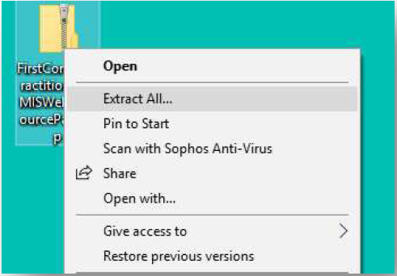

1. Open EMIS Web and click on the EMIS Bubble and select **Configuration** >

**Template Manager**:

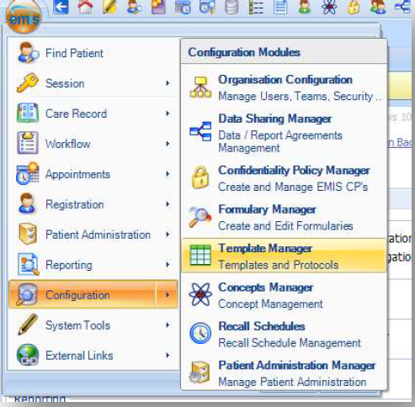

1. In the **Templates and Protocols** section click **Add** and then **Folder**:

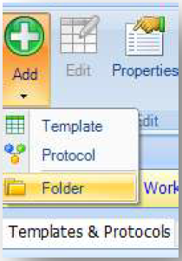

1. Name the folder **‘First Contact Practitioner’**
2. Open the folder and then click the **Import** button:

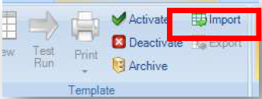

1. Navigate to where the **Resource Pack** has been extracted to and open the folder. In here you will see a file called **FCP Protocol – v2**, highlight this and click the **Open** button
2. You will now be asked where you would like to store the document templates. These are the referral forms which are required for the FCP to referral in to the MSK service, as indicated
3. Pick a folder in the hierarchy within EMIS, then click **New Folder** and name it **FCP**
4. Now press the **Select** button:

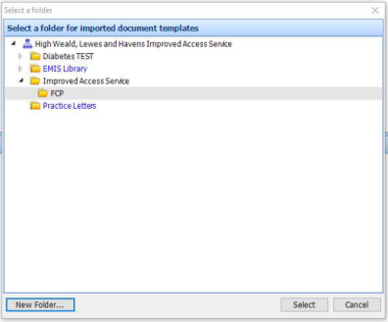

**The Protocol, Template and Documents have now been installed into your system.**

1. **Setting up the FCP Template Pop-ups (Protocol)**

**Note**

This section was written with the First Contact Practitioner in mind; however, it is available for anyone to read so that they can understand how the Resources are to be used within their Clinical Systems

In order to make the full use of the System Resources that have been developed, it is necessary for the FCP to undertake a small amount of configuration within their own EMIS Profile. This will need to be done at each EMIS practice you work at.

The pop-ups (protocol) have been developed to ensure that no steps are missed during the completion of your patient consultation. The protocol will need adding to the Launcher within your EMIS profile; to do this:

1. Load up a “Dummy Patient” in the clinical system. (Check with your practice for dummy patients then Find Patient, F6)
2. Once loaded, press **F12** on your keyboard. The **Protocol Launcher** will now appear on the right-hand side of the screen:

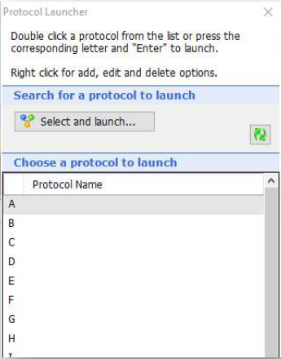

1. Right-click on the next available alphabet letter, then click **Add:**

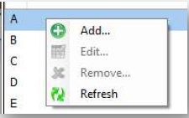

1. Type **FCP** into the Search box and hit return
2. You should see the **FCP Protocol – v2** option, double click on it:

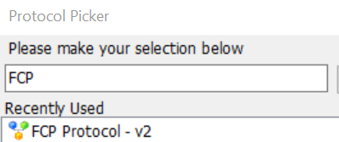

1. The **FCP Protocol – v2** protocol option should now appear on the list next to the letter that you chose:

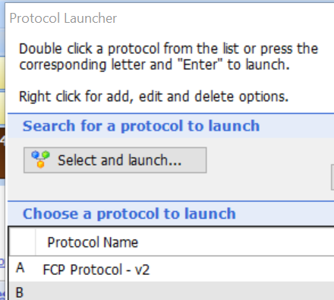

1. In order to access this when in patient consultation, press **F12** and double click **FCP Protocol – v2** or press F12 and the letter that you assigned it to (e.g. ‘A’).